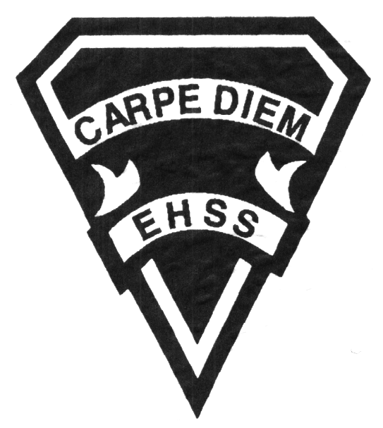

# **CHG38M Genocide and Crimes Against Humanity**

**Evaluation Profile and Outline**

**2020/2021**

**Genocide and Crimes Against Humanity**

**Social Sciences Department**

## Earl Haig

SecondarySchool

**Course Description/Rationale/Overview:** This course investigates examples of genocide in the twentieth and twenty-first centuries, including the Holocaust, Armenia, and Rwanda. Students will investigate the terms genocide, crimes against humanity, and war crimes and explore them through the lens of historical analysis. Students will examine identity formation and how "in groups" and "out groups" are created, including an analysis of how bias, stereotypes, prejudice, and discrimination impact on various groups. Throughout the course, students will gain an understanding of the role of perpetrator, victim, bystander, rescuer, opportunist, and resister.

**Assessment and Evaluation Strategies**

Students will also be expected to complete assessment activities of a formative nature in order to learn and to practice the specific expectations that will compose the summative evaluations. Examples of formative assessment may include homework checks, quizzes, peer assessment, presentations, reflection writing, role-play scenarios and observation.

Each unit or strand of the course will be evaluated using summative evaluations. Examples of summative evaluations are tests, case studies, interviews, reports, presentations, seminars, debates, research, and other writing assignments.

**Class Requirements:**

Students should have materials specified by the subject teacher at the beginning of the year.

There is no textbook for this course. Selected readings from various sources have been chosen to enhance the students’ understanding of the course.

**Late and/or Missed Evaluation**

##### Late Assignments*

For each assignment, the teacher will inform students of the due date. The teacher may decide to create an ultimate deadline. If an assignment *is submitted after the deadline, the teacher may deduct marks up to and including the full value of the assignment*

.

**Missed Tests**

It is the student’s responsibility to make arrangements, ahead of time, for any tests/quizzes that are missed. If a student misses a test/quiz for an unforeseen reason such as illness, the student must bring a note signed by a parent or guardian**. Alternatively, a medical certificate may be requested by the teacher.** The student must be prepared to write the test/quiz immediately upon return to school at a time determined by the teacher. Once the tests/quizzes have been evaluated and returned, students will not be able to make up a missed test - a mark of zero will be assigned.

**Learning Skills\***

**Responsibility** – meets deadlines; takes responsibility for own behaviour

**Organization** – establishes priorities and manages time; uses information, technology, and resources top complete tasks time management

**Independent Work** – follows instruction with minimal supervision; uses class time appropriately to complete tasks

**Collaboration** – accepts an equitable share of work in a group; builds healthy peer relationships; works with others to achieve group goals

**Initiative** – looks for opportunities for learning; demonstrates curiosity; approaches new tasks with a positive attitude

**Self-regulation** – sets own goals and monitors own progress; seeks assistance with needed; makes an effort with responding to challenges

**Subject-Specific/Department Information**

Teachers in the Social Sciences Department can be reached at (416) 395-3210, ext. 20075 or 20085. Parents wishing to meet with a teacher are requested to make an appointment with the teacher prior to coming to the school.

###### Final Mark

The final mark for this course will be determined based upon an accumulation of marks from unit summative activities and from a final summative evaluation

**Course Work 85%**

This is a culmination of evaluations that have been completed throughout the year. It may include tests, presentations, research, or topic specific assignments.

**Research Project 15%**

This will be completed throughout the course and will consist of multiple, evaluated stages, culminating in a final product.

**Achievement Categories and Weighting**

* **Knowledge / Understanding – 30%**

Knowledge of facts and terms; understanding of concepts, principles, guidelines and strategies; understanding of relationships among concepts.

* **Application – 30%**

Synthesizing knowledge and understanding into new and familiar contexts as well as making connections between various contexts.

* **Thinking Inquiry – 25%**

Formulating questions; planning, selecting strategies and resources; analyzing and interpreting information, and forming conclusions.

* **Communication – 20%**

Communication of information and ideas, communication for different audiences, use of various forms of communication.

*From: Ontario Ministry of Education. *Growing Success: Assessment, Evaluation, and Reporting in Ontario Schools*. Toronto: Ministry of Education, 2010, 11.



**2020/2021**

**Genocide and Crimes Against Humanity**

**Social Sciences Department**

# **CHG38M**

**Evaluation Profile & Outline**

## Earl Haig

SecondarySchool

**Course Outline:**

**Unit 1: Foundations**

This unit examines identity and belonging and the ways in which these elements set the stage for genocide. How they influence the choices people make. It will examine the tensions between personal morality, values and the need to belong. How a society shifts from cohesive to divisive and how these elements present in our day to day lives.

**Unit 2: The Holocaust**

This unit examines the events in Germany that begin with the relatively inclusive Weimar Republic. The will explore the rise of the NAZI party and the methods they used to create division amongst Germans. It will go on to examine the methods the NAZI’s employed to perpetrate the Holocaust as well as some of those who opposed and took action against the state. Lastly, it will explore the way the world dealt with the genocide, through the creation of the United Nations and international laws for human rights.

**Unit 3: Rwanda**

This unit looks at the Rwandan Genocide. This will begin with Dutch colonial rule and how their methods of control left a legacy which directly contributed to the genocide. It will follow the events from colonialism through to independence and the collapse of the government and the genocide. There will be a focus on the role the international community played – or failed to play in the halting of the mass murders. And examine the lessons and new roles assumed by the United Nations in response to these events.

**Unit 4: The Armenian Genocide**

This unit examines the Armenian Genocide beginning from the relative cohesiveness of the Ottoman Empire. It will follow the timeline as the Armenian population becomes isolated from the rest of Ottoman society, have their right and freedoms taken and then murdered. It will apply the theories of identity and belonging to help understand how this shift in Ottoman society happened.

**Unit 5: Individual Study and Active Citizenship**

This unit will be the Culminating Project for the course. Students will independently explore a Genocide of their choice. They will examine events with a focus on the themes we have studied throughout the course. They will then need to consider the role Canada and the world played in halting events as well as actions they might have taken. Lastly, students will reflect on the role of individual citizens in Canada have for influencing decisions of their government.